DARANIDHARAN
192412673
ECA5605- 5G/6G-COMMUNICATION
EXP 1
OBJECTIVE 1
CODE :

clc; clear; close all;
fs = 1000;
t = 0:1/fs:1;
TBW = 600;
Users = 3;
CBW = TBW/Users;
fc = [100 300 500];
m = sin(2*pi*10*t);
s1 = m .* cos(2*pi*fc(1)*t);
s2 = m .* cos(2*pi*fc(2)*t);
s3 = m .* cos(2*pi*fc(3)*t);
subplot(2,1,1)
plot(t,s1,'r',t,s2,'g',t,s3,'b'), grid on
title('FDMA Channel Allocation')
xlabel('Time (s)')
ylabel('Amplitude')
subplot(2,1,2)
bar(1:Users, CBW*ones(1,Users)), grid on
xlabel('Users')
ylabel('Channel Bandwidth (kHz)')
title('Channel Bandwidth per User')

OUTPUT

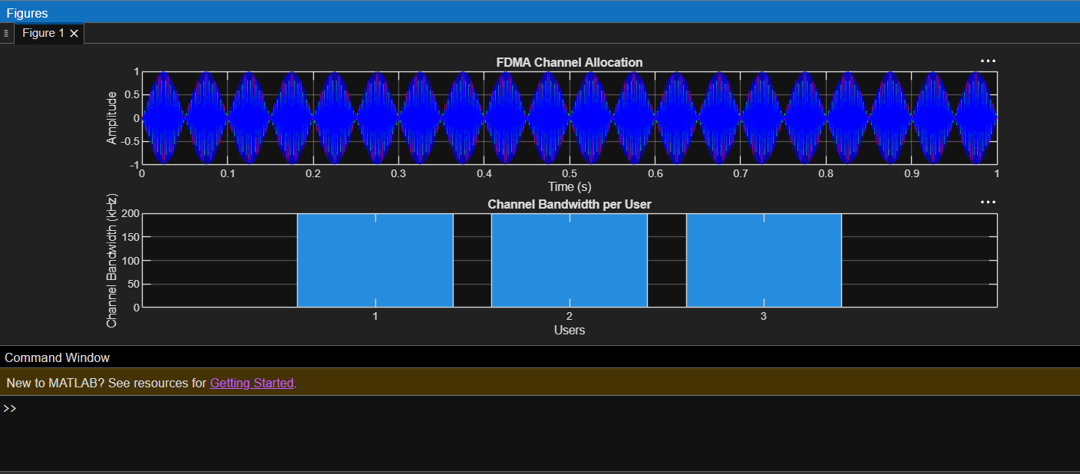

Objective 2
CODE

clc; clear; close all;
BW = 200; % Channel Bandwidth (kHz)
Users = 3;
M = 2; % BPSK Modulation
DataRate = BW*log2(M); % Data Rate (kbps)
Rate = DataRate*ones(1,Users);
disp(' User Data Rate (kbps)')
disp([(1:Users)' Rate'])
figure
bar(1:Users,Rate)
xlabel('Users')
ylabel('Data Rate (kbps)')
title('FDMA Data Rate for Each User')
grid on

OUTPUT: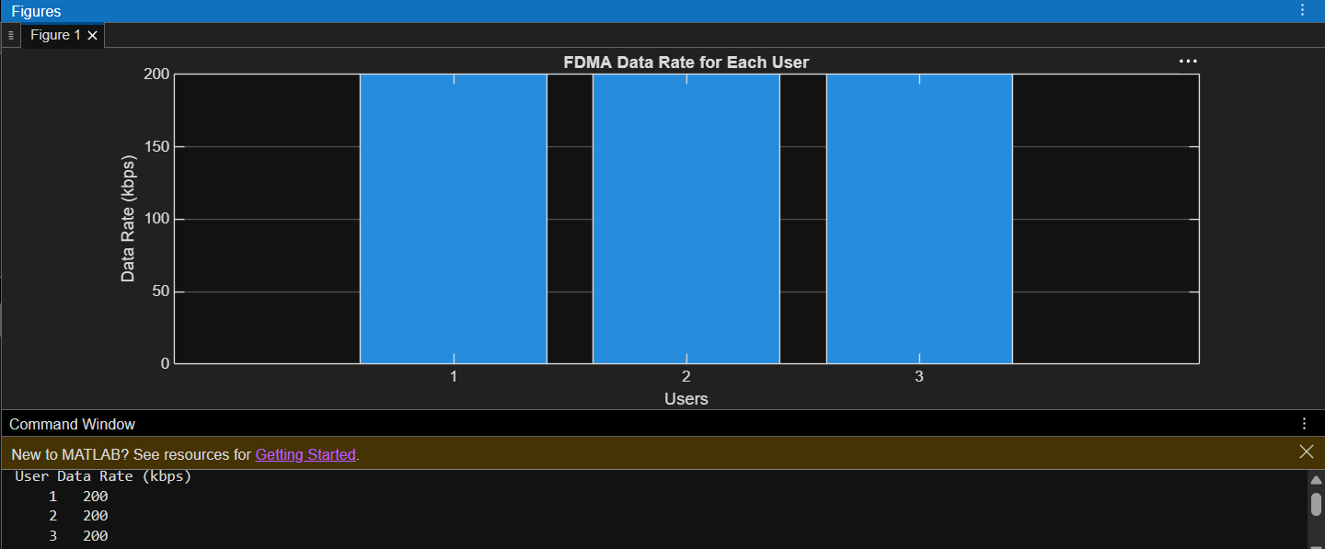

Objective 3
CODE

clc; clear; close all;
Ps = 1; % Signal Power (W)
Pn = [0.1 0.05 0.01]; % Noise Power (W)
Users = 1:3;
SNR = 10*log10(Ps./Pn); % SNR in dB
disp('User Noise Power(W) SNR(dB)')
disp([Users' Pn' SNR'])
figure
bar(Users,SNR)
xlabel('Users')
ylabel('SNR (dB)')
title('Signal-to-Noise Ratio of FDMA Users')
grid on
OUTPUT
